Radius Equality
# Source: AI Source: Provided by: [Data Path: Persons Table -> ID Column: 1, Name_En Column: Motasem Essam] -> From: [ChatGPT] on [7/25/2026]
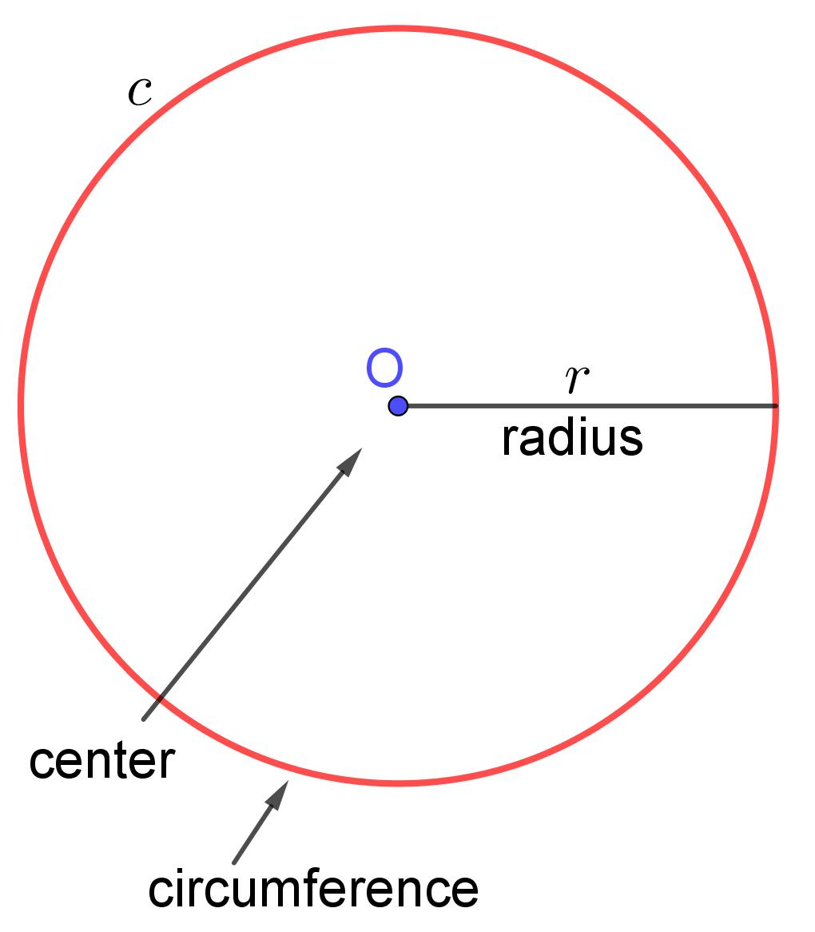
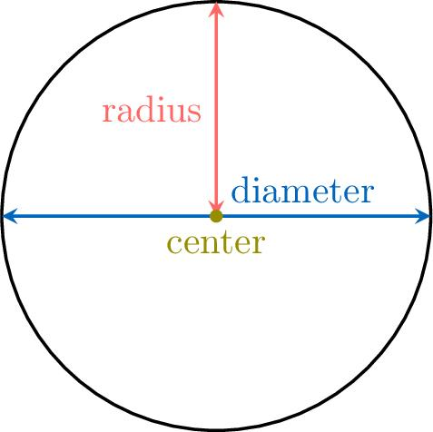
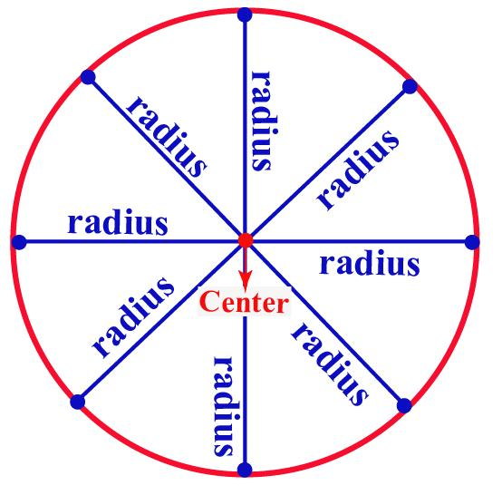
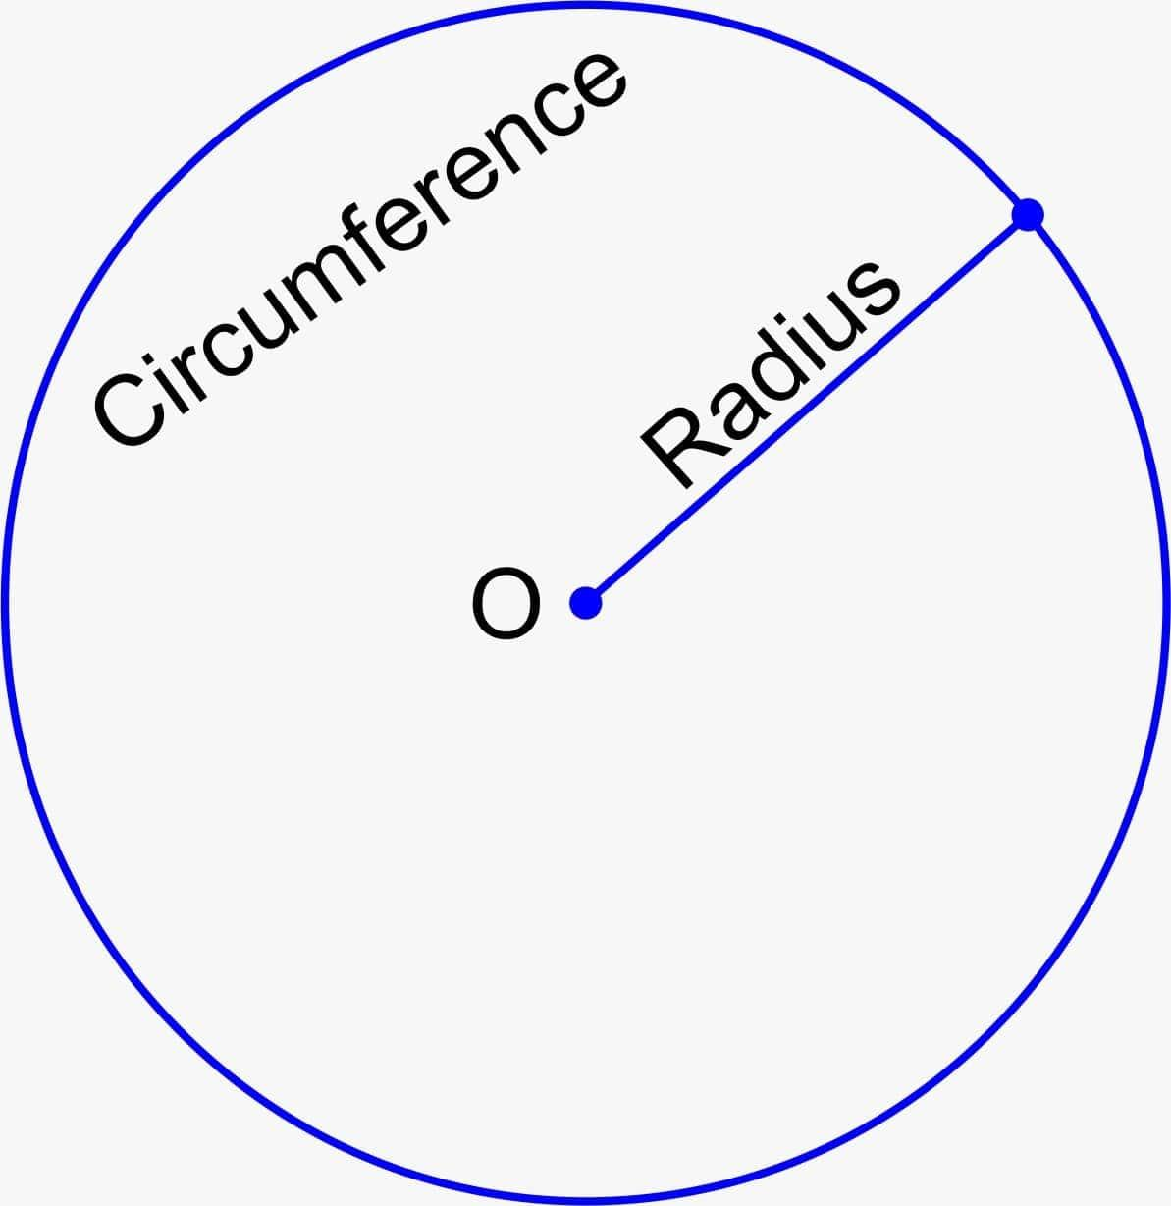
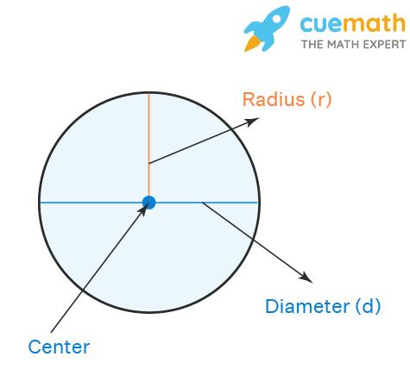

Definition
# Source: AI Source: Provided by: [Data Path: Persons Table -> ID Column: 1, Name_En Column: Motasem Essam] -> From: [ChatGPT] on [7/25/2026]
Radius Equality is an exact geometric relationship in which two or more radii have the same length.
For two radii $r_{1}$and $r_{2}$:
$$\boxed{r_{1}=r_{2}}$$
A radius is a line segment connecting the center of a circle to a point on the circle.
For a circle:
$$\boxed{d=2r}$$
Therefore, equal radii also mean equal diameters:
$$\boxed{r_{1}=r_{2} ⟺ d_{1}=d_{2}}$$

Simple Definition
# Source: AI Source: Provided by: [Data Path: Persons Table -> ID Column: 1, Name_En Column: Motasem Essam] -> From: [ChatGPT] on [7/25/2026]
Radius Equality means that two or more radii have exactly the same length.
For example:
$$r_{1}=6\text{ cm}$$
and:
$$r_{2}=6\text{ cm}.$$
Therefore:
$$\boxed{r_{1}=r_{2}=6\text{ cm}}.$$

Fundamental Concept
# Source: AI Source: Provided by: [Data Path: Persons Table -> ID Column: 1, Name_En Column: Motasem Essam] -> From: [ChatGPT] on [7/25/2026]
Every radius of a particular circle has the same length.
If $O$is the center of a circle and $A,B,C,D$are points on the circle, then:
$$\boxed{OA=OB=OC=OD=r}$$
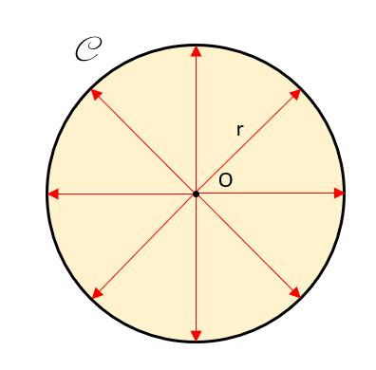
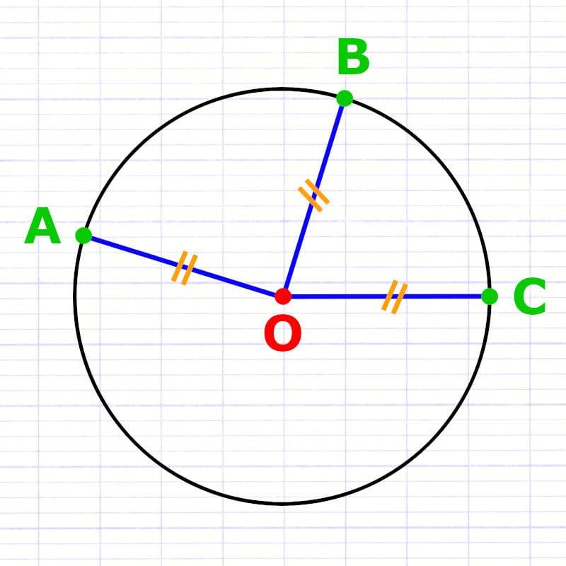
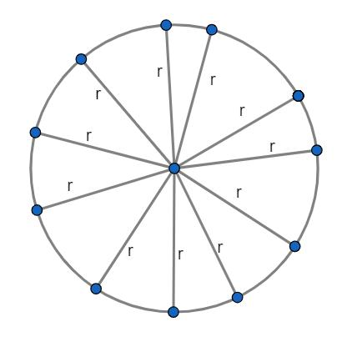
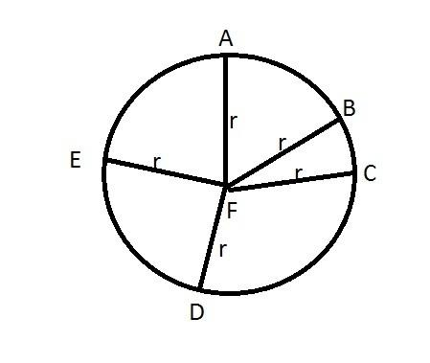
This is one of the fundamental defining properties of a circle.
For two circles:
$$r_{1}=r_{2}$$
means they have the same size.
Because:
$$d=2r,$$
we also have:
$$d_{1}=d_{2}.$$

Classification of Radius Equality
# Source: AI Source: Provided by: [Data Path: Persons Table -> ID Column: 1, Name_En Column: Motasem Essam] -> From: [ChatGPT] on [7/25/2026]
A practical classification is:
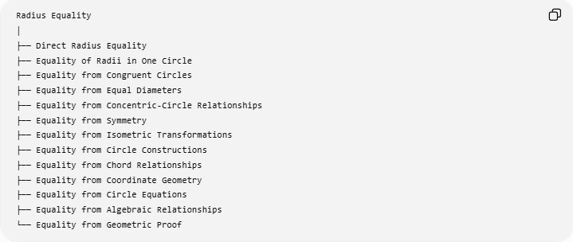
Radius Equality
│
├── Direct Radius Equality
├── Equality of Radii in One Circle
├── Equality from Congruent Circles
├── Equality from Equal Diameters
├── Equality from Concentric-Circle Relationships
├── Equality from Symmetry
├── Equality from Isometric Transformations
├── Equality from Circle Constructions
├── Equality from Chord Relationships
├── Equality from Coordinate Geometry
├── Equality from Circle Equations
├── Equality from Algebraic Relationships
└── Equality from Geometric Proof
This is a practical classification, rather than a universally standardized formal taxonomy.

Direct Radius Equality
# Source: AI Source: Provided by: [Data Path: Persons Table -> ID Column: 1, Name_En Column: Motasem Essam] -> From: [ChatGPT] on [7/25/2026]
Definition
The equality is directly given:
$$\boxed{r_{1}=r_{2}}$$
Example
Circle A has:
$$r_{A}=5\text{ cm}$$
and Circle B has:
$$r_{B}=5\text{ cm}.$$
Therefore:
$$\boxed{r_{A}=r_{B}=5\text{ cm}}.$$
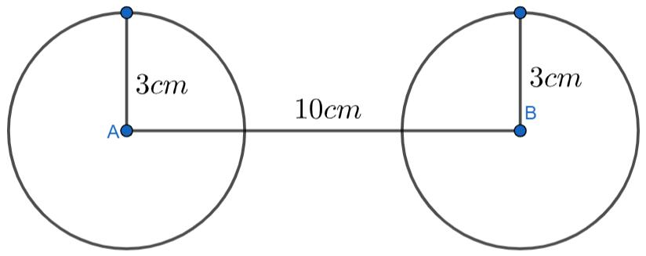
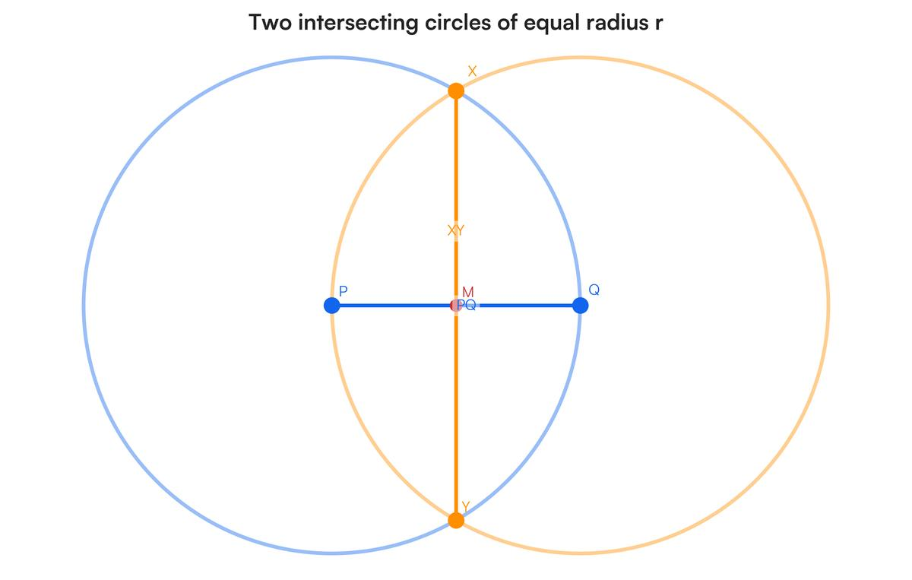
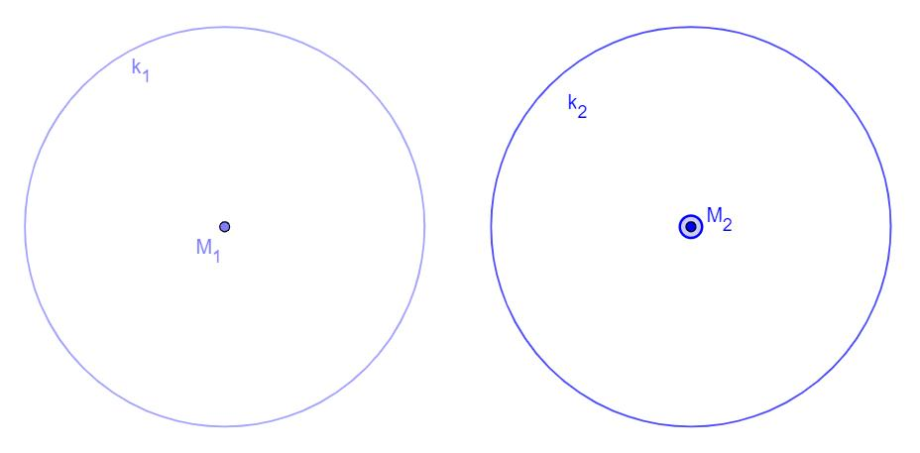

Equality of Radii in One Circle
# Source: AI Source: Provided by: [Data Path: Persons Table -> ID Column: 1, Name_En Column: Motasem Essam] -> From: [ChatGPT] on [7/25/2026]
Definition
All radii of the same circle are equal in length.
If $O$is the center:
$$\boxed{OA=OB=OC=OD}$$
for points $A,B,C,D$on the circle.
Example
Suppose a circle has radius:
$$r=8\text{ cm}.$$
Then every radius is:
$$8\text{ cm}.$$
Thus:
$$\boxed{OA=OB=OC=8\text{ cm}}.$$
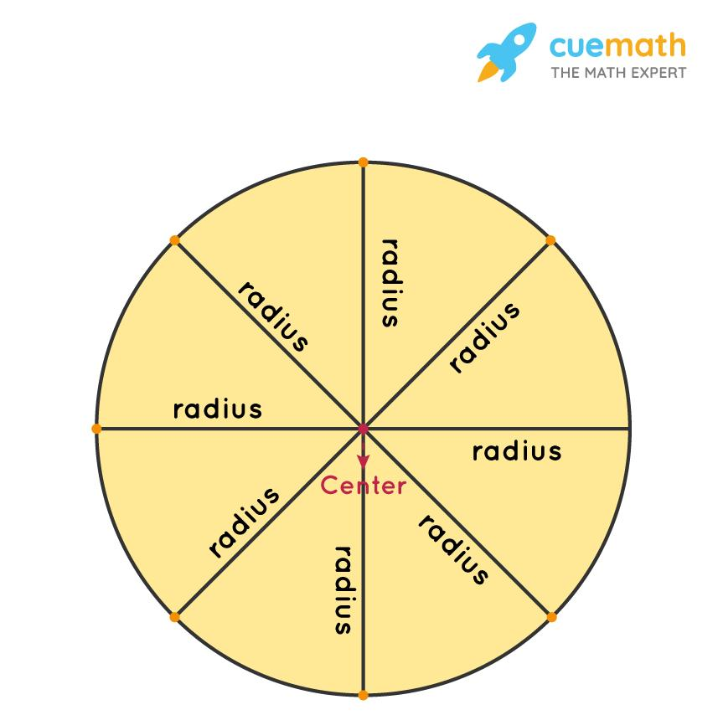
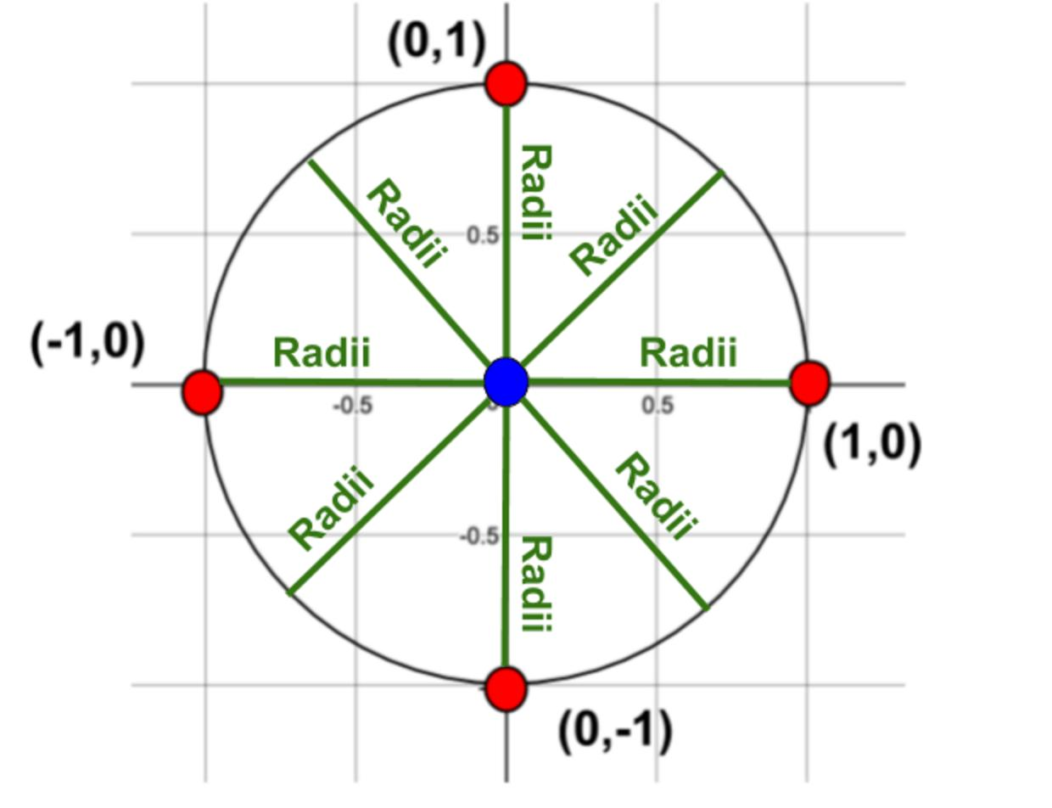
Important
The radii can have different directions, but they have the same length.

Equality from Congruent Circles
# Source: AI Source: Provided by: [Data Path: Persons Table -> ID Column: 1, Name_En Column: Motasem Essam] -> From: [ChatGPT] on [7/25/2026]
Two congruent circles have equal radii:
$$\boxed{C_{1}≅C_{2}⇒r_{1}=r_{2}}$$
Example
If:
$$C_{1}≅C_{2}$$
and:
$$r_{1}=7\text{ cm},$$
then:
$$\boxed{r_{2}=7\text{ cm}}.$$
Therefore:
$$\boxed{r_{1}=r_{2}}.$$
For circles, the converse also holds:
$$\boxed{r_{1}=r_{2} ⟺ C_{1}≅C_{2}}.$$
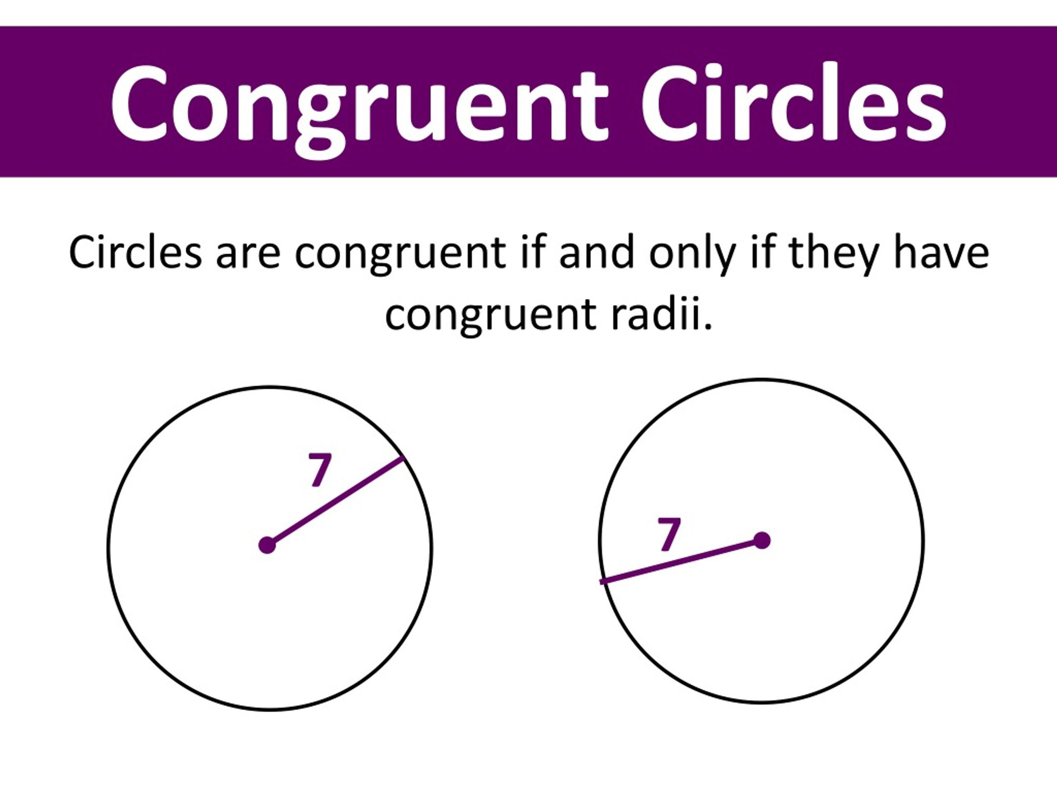
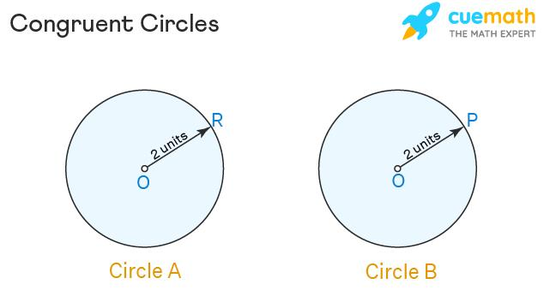
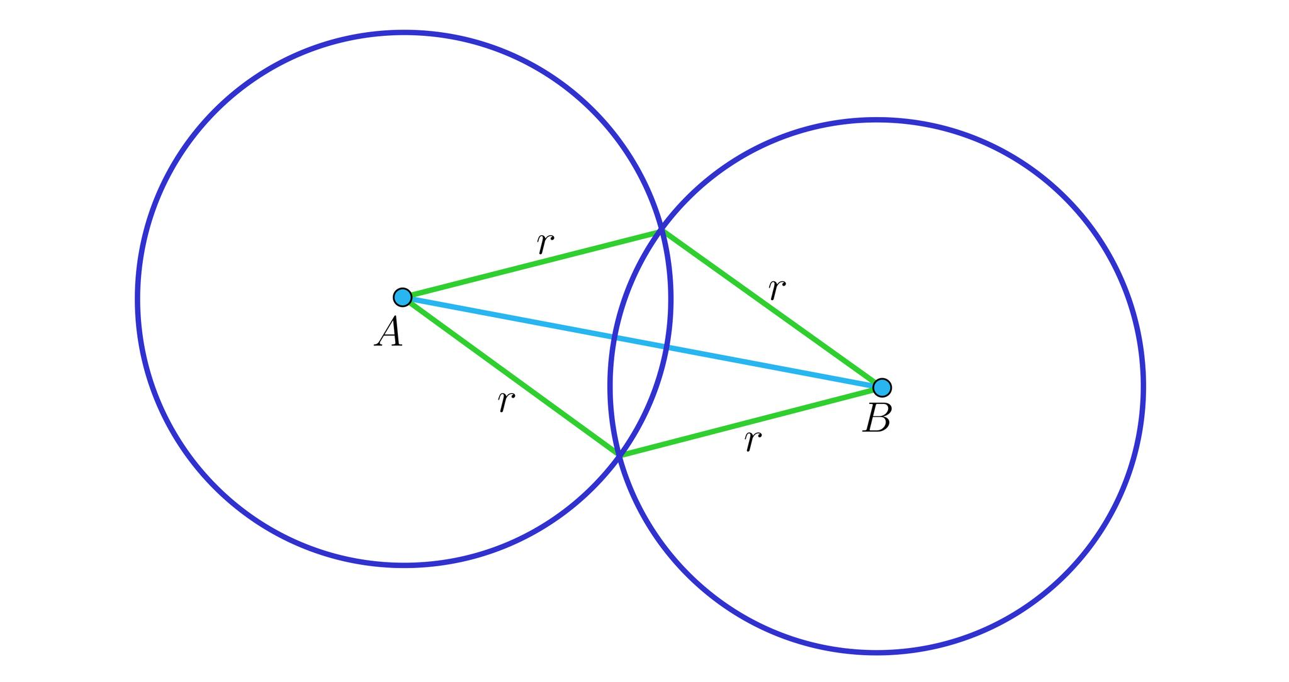
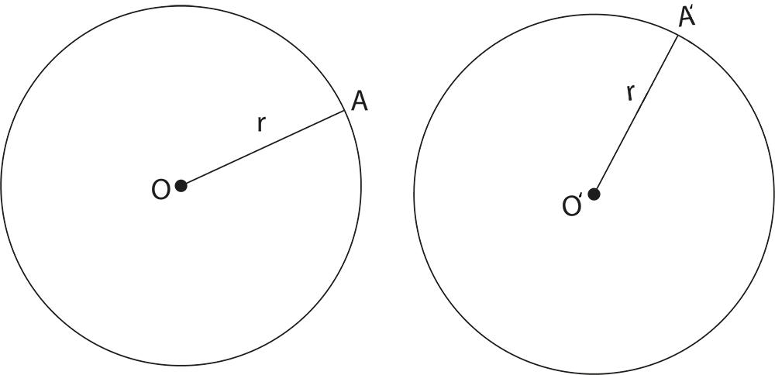

Equality from Equal Diameters
# Source: AI Source: Provided by: [Data Path: Persons Table -> ID Column: 1, Name_En Column: Motasem Essam] -> From: [ChatGPT] on [7/25/2026]
Since:
$$d=2r,$$
we can solve for the radius:
$$\boxed{r=\frac{d}{2}}.$$
Therefore:
$$d_{1}=d_{2}$$
implies:
$$\frac{d_{1}}{2}=\frac{d_{2}}{2}$$
and:
$$\boxed{r_{1}=r_{2}}.$$
Example
Circle A:
$$d_{A}=20\text{ cm}.$$
Circle B:
$$d_{B}=20\text{ cm}.$$
Therefore:
$$r_{A}=r_{B}=10\text{ cm}.$$
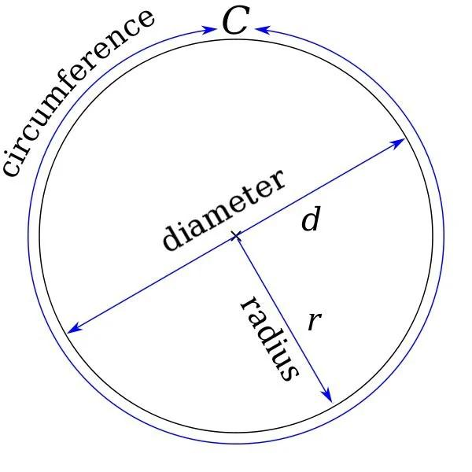
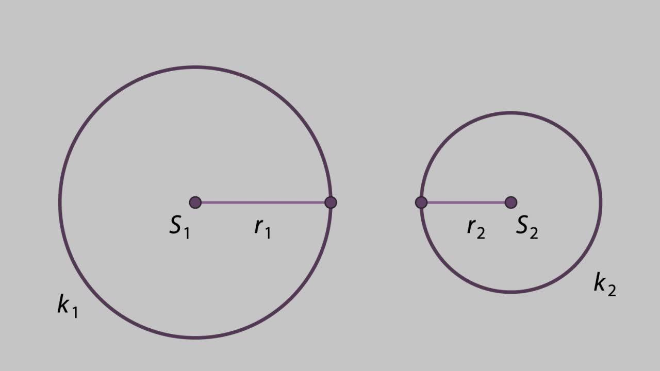
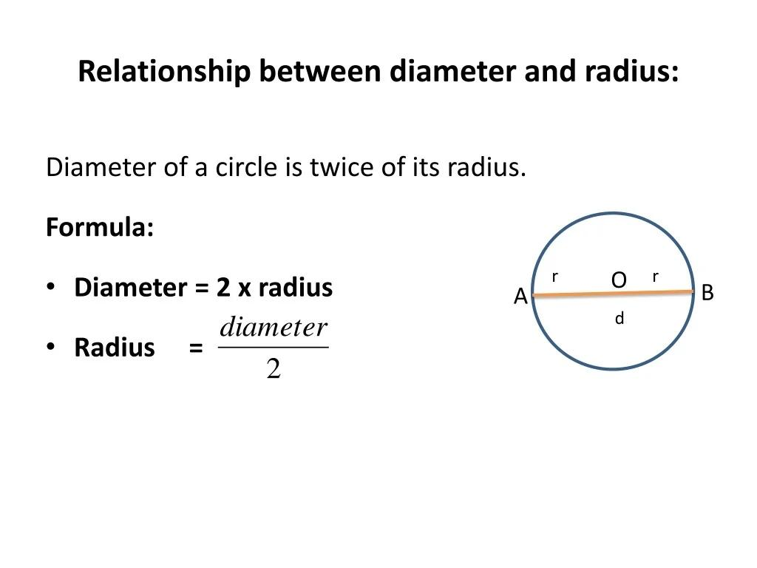

Radius Equality and Diameter Equality
# Source: AI Source: Provided by: [Data Path: Persons Table -> ID Column: 1, Name_En Column: Motasem Essam] -> From: [ChatGPT] on [7/25/2026]
The two relationships are equivalent:
$$\boxed{r_{1}=r_{2} ⟺ d_{1}=d_{2}}$$
because:
$$d_{1}=2r_{1}$$
and:
$$d_{2}=2r_{2}.$$
Example
If:
$$r_{1}=r_{2}=4,$$
then:
$$d_{1}=d_{2}=8.$$
Conversely, if:
$$d_{1}=d_{2}=8,$$
then:
$$r_{1}=r_{2}=4.$$

Equality from Concentric Circles
# Source: AI Source: Provided by: [Data Path: Persons Table -> ID Column: 1, Name_En Column: Motasem Essam] -> From: [ChatGPT] on [7/25/2026]
Concentric circles have the same center but generally have different radii.
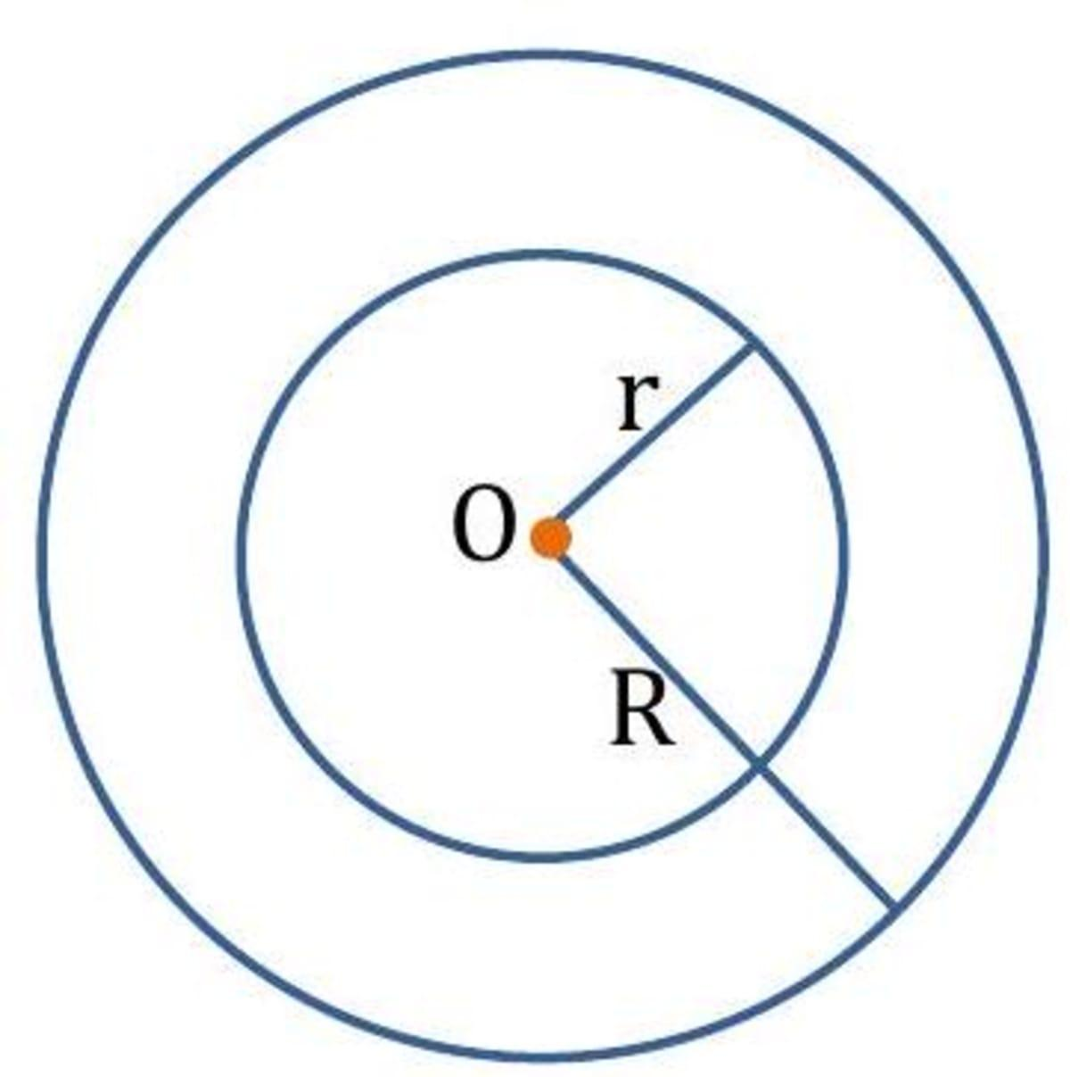
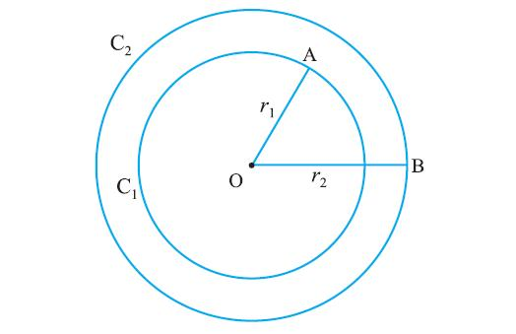
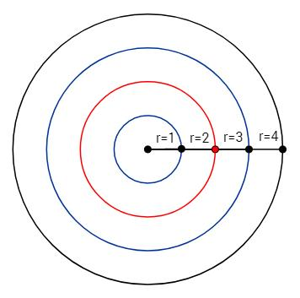
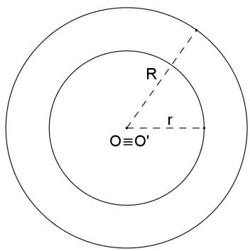
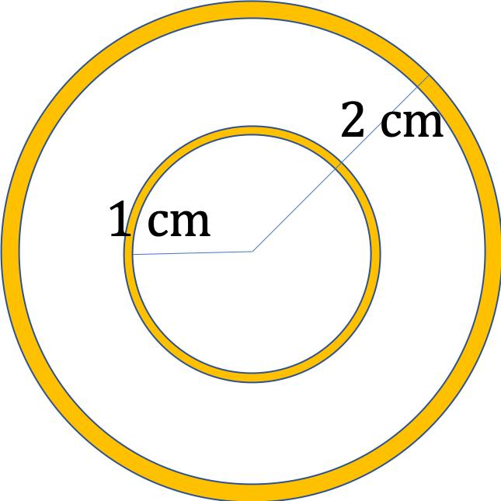
If two concentric circles have:
$$r_{1}≠r_{2},$$
then their radii are not equal.
For example:
$$r_{1}=5, r_{2}=8.$$
They are concentric, but:
$$\boxed{r_{1}≠r_{2}}.$$
Important
$$\boxed{\text{Concentric}⇏\text{Equal Radii}}$$
If two concentric circles have equal radii, they coincide rather than form two distinct circles.

Equality from Symmetry
# Source: AI Source: Provided by: [Data Path: Persons Table -> ID Column: 1, Name_En Column: Motasem Essam] -> From: [ChatGPT] on [7/25/2026]
Symmetry can produce equal radii.
For example, reflection symmetry through a diameter maps one radius to another radius of the same circle.
Because reflection preserves length:
$$\boxed{OA=OB}.$$
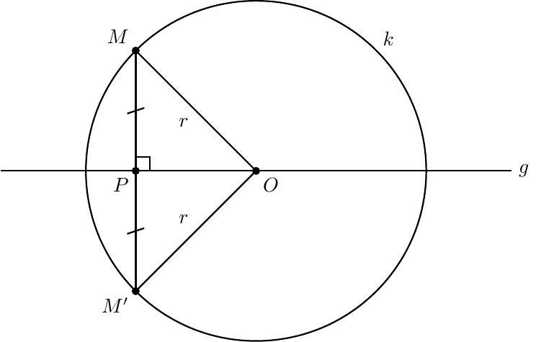
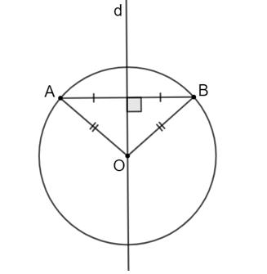
More generally:
$$\boxed{\text{Symmetry transformation}⇒\text{Equal corresponding lengths}}$$
when the corresponding radii are mapped onto one another.

Equality from Isometric Transformations
# Source: AI Source: Provided by: [Data Path: Persons Table -> ID Column: 1, Name_En Column: Motasem Essam] -> From: [ChatGPT] on [7/25/2026]
Isometries preserve distances.
Examples include:
- Translation
- Rotation
- Reflection
- Glide reflection
If a circle with radius $r$is transformed by an isometry, its image has the same radius:
$$\boxed{r^{'}=r}.$$
Example
Original circle:
$$r=10\text{ cm}.$$
After rotation:
$$r^{'}=10\text{ cm}.$$
Therefore:
$$\boxed{r=r^{'}}.$$
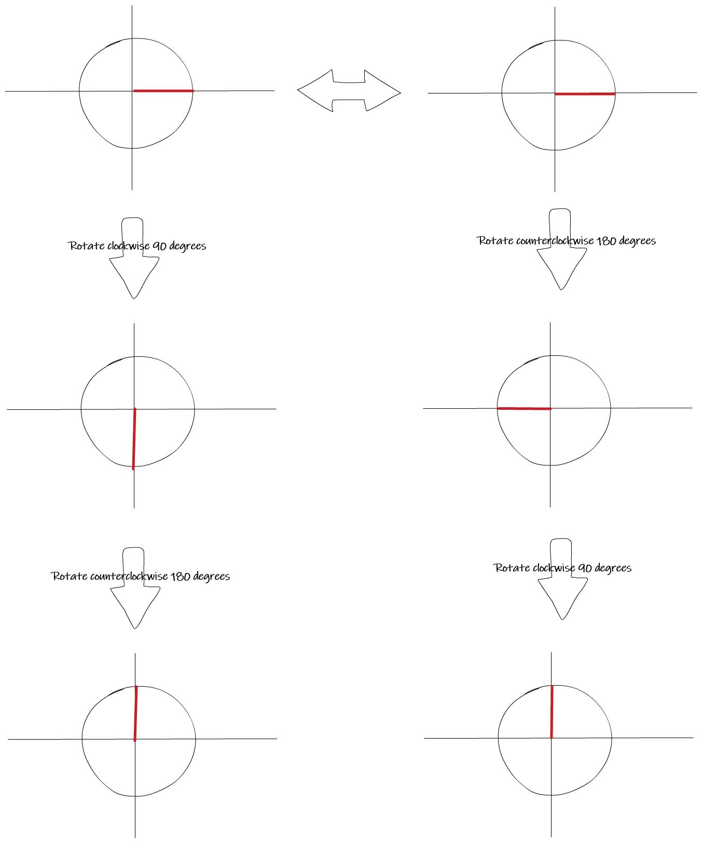
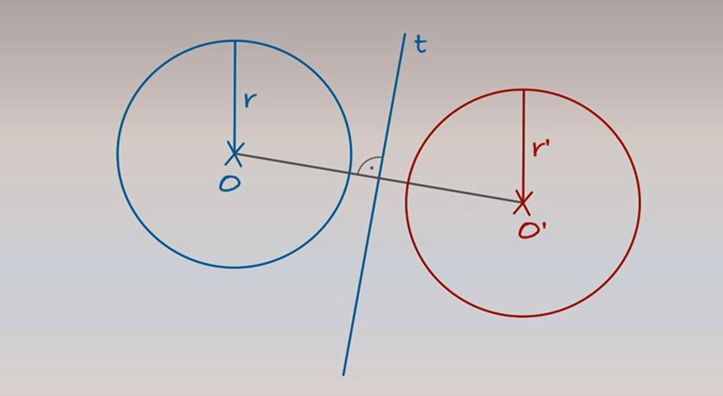
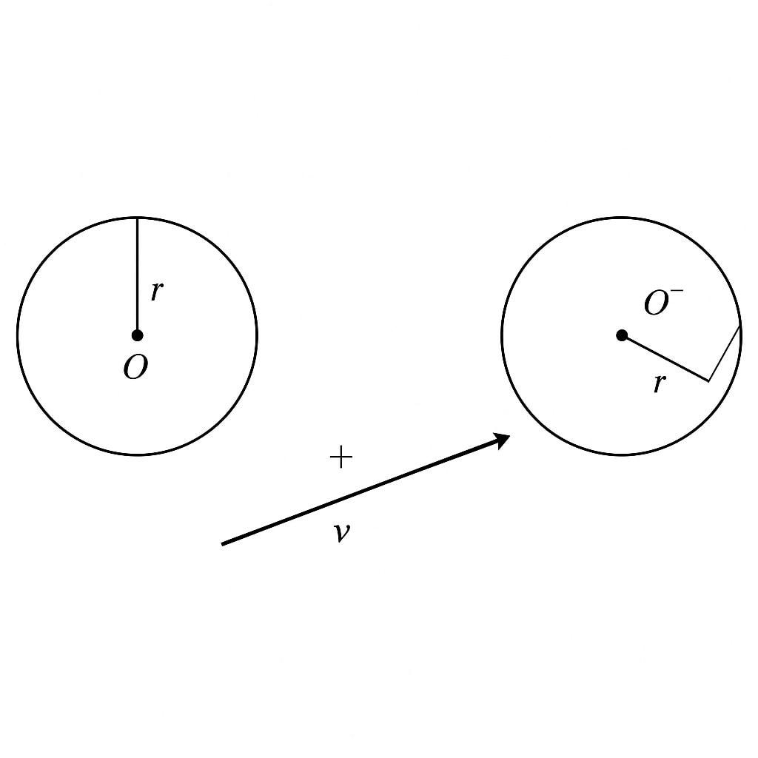
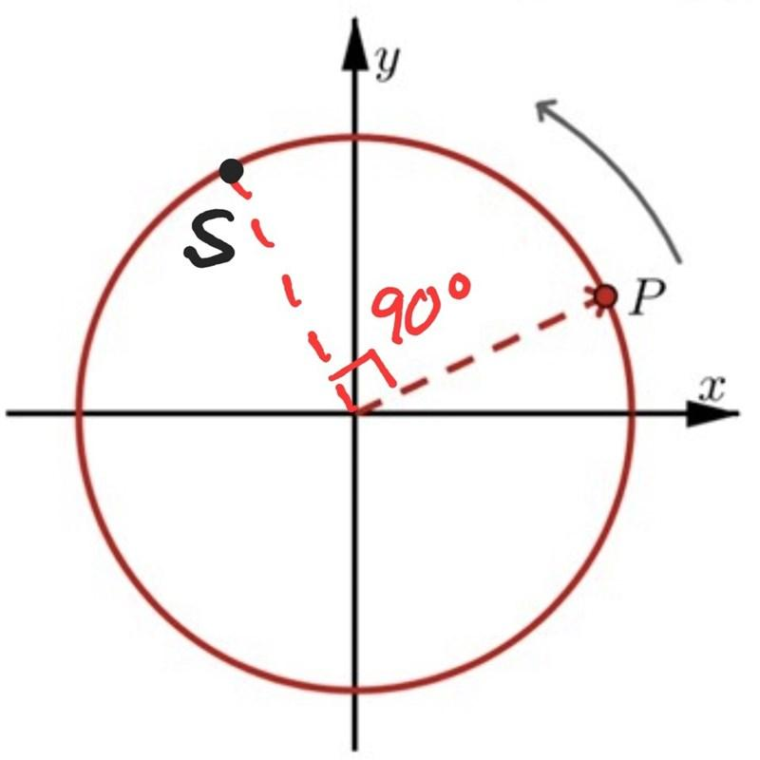
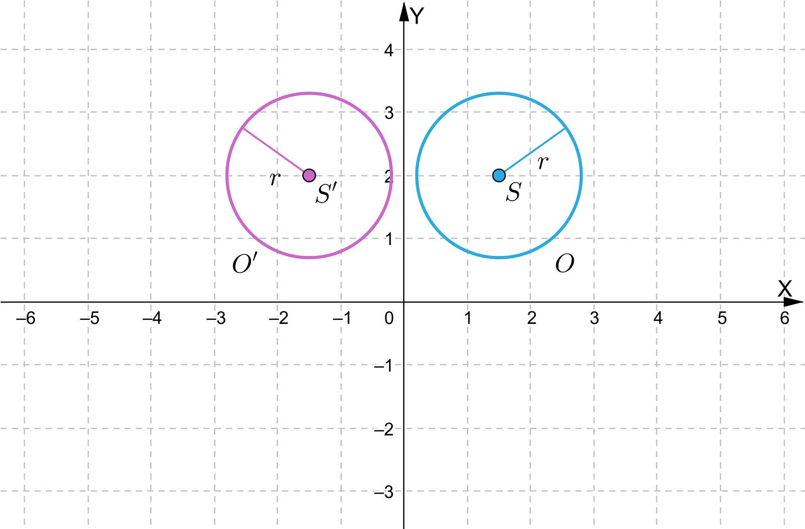
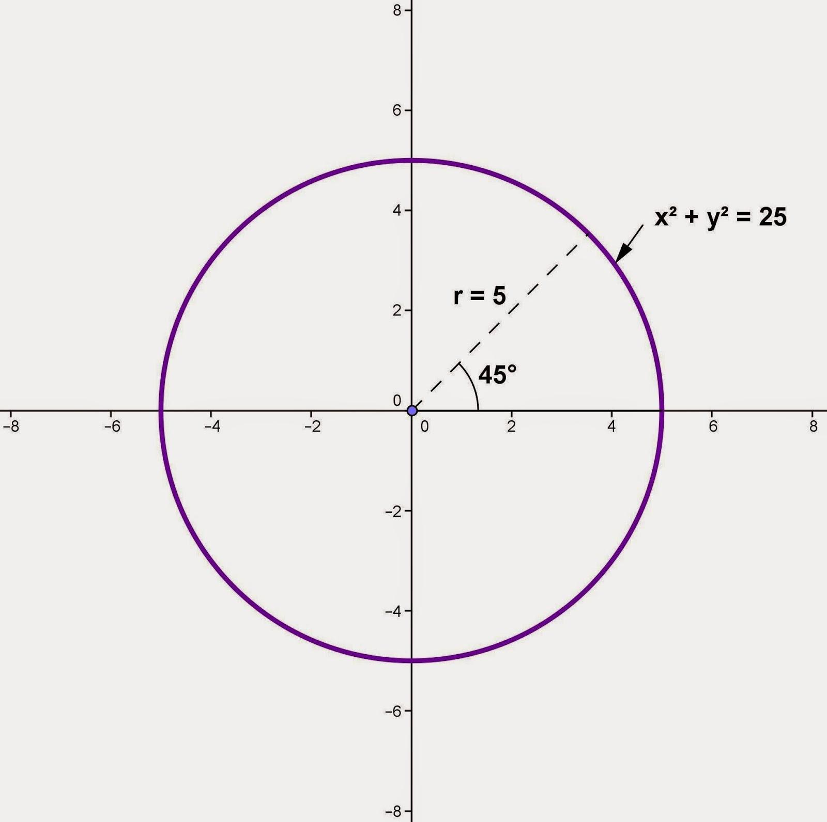

Radius Equality Under Scaling
# Source: AI Source: Provided by: [Data Path: Persons Table -> ID Column: 1, Name_En Column: Motasem Essam] -> From: [ChatGPT] on [7/25/2026]
Scaling changes radius according to the scale factor $k$:
$$\boxed{r^{'}=kr}.$$
Example
Original:
$$r=5.$$
Scale factor:
$$k=3.$$
Then:
$$r^{'}=3\left(5\right)=15.$$
Thus:
$$\boxed{r^{'}≠r}.$$
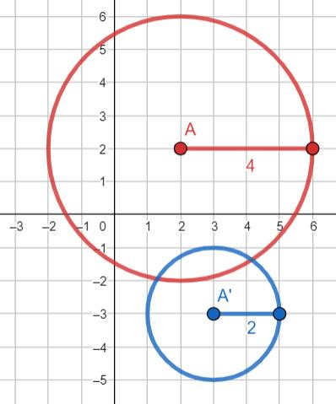
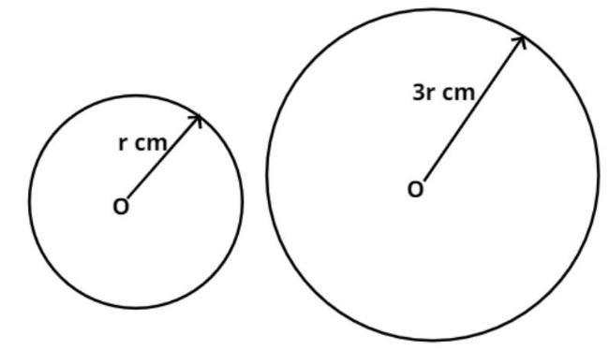
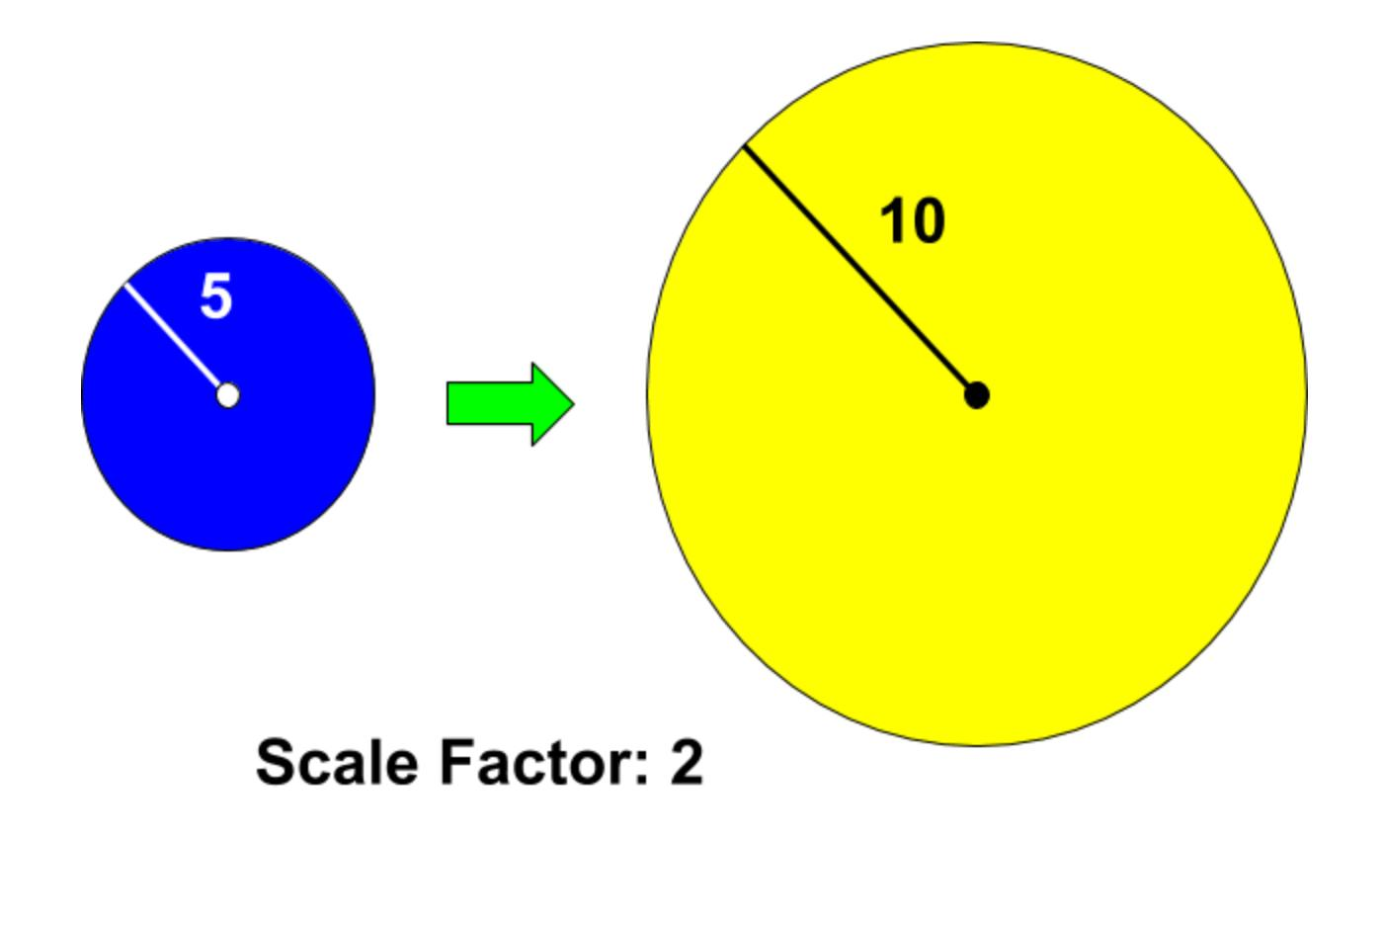
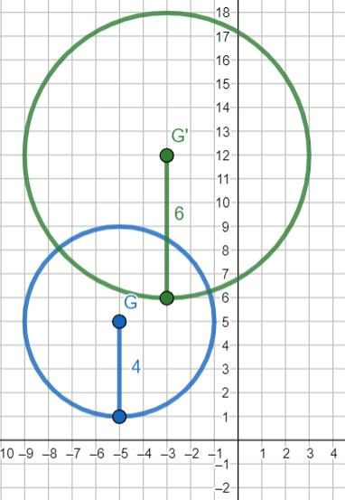
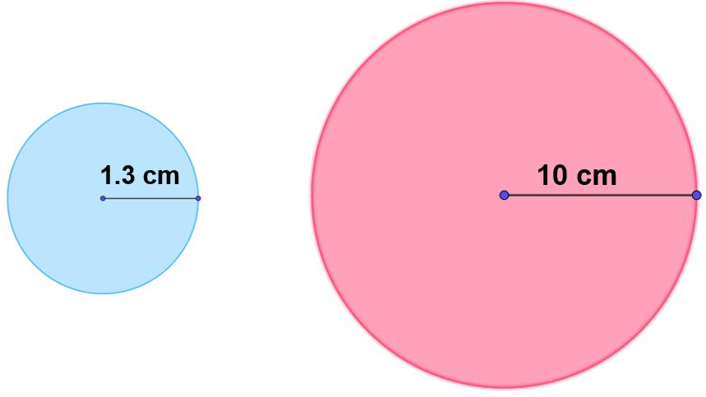
Radius equality after scaling occurs only when:
$$\boxed{k=1}$$
for a nonzero radius.

Radius Equality from Circle Construction
# Source: AI Source: Provided by: [Data Path: Persons Table -> ID Column: 1, Name_En Column: Motasem Essam] -> From: [ChatGPT] on [7/25/2026]
When constructing a circle with a compass, the compass opening determines the radius.
If two circles are constructed using the same compass opening, then their radii are equal:
$$\boxed{r_{1}=r_{2}}.$$
Example
A compass is set to $4$cm.
Circle A is drawn.
Without changing the compass opening, Circle B is drawn.
Then:
$$\boxed{r_{A}=r_{B}=4\text{ cm}}.$$
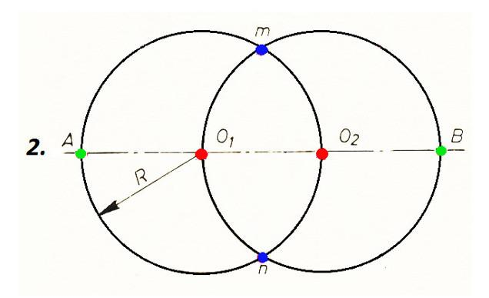
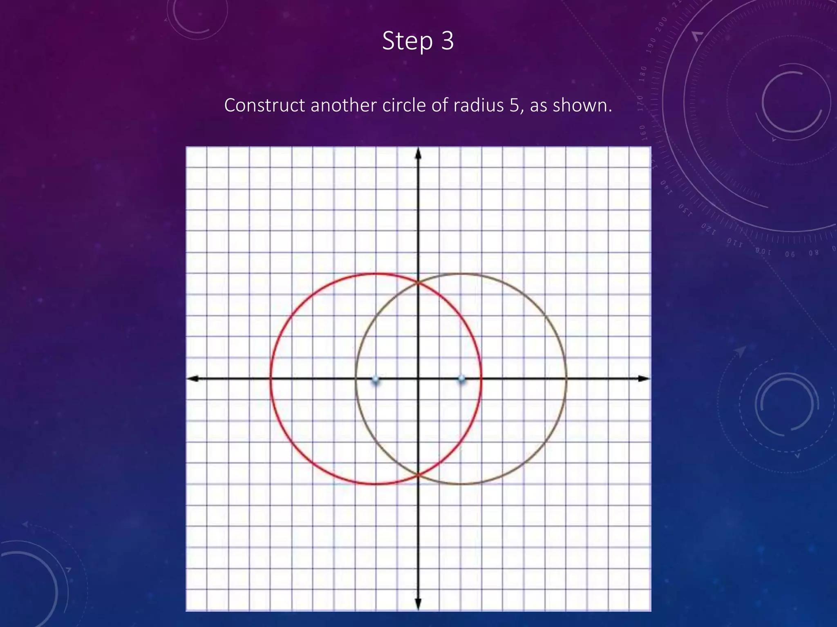
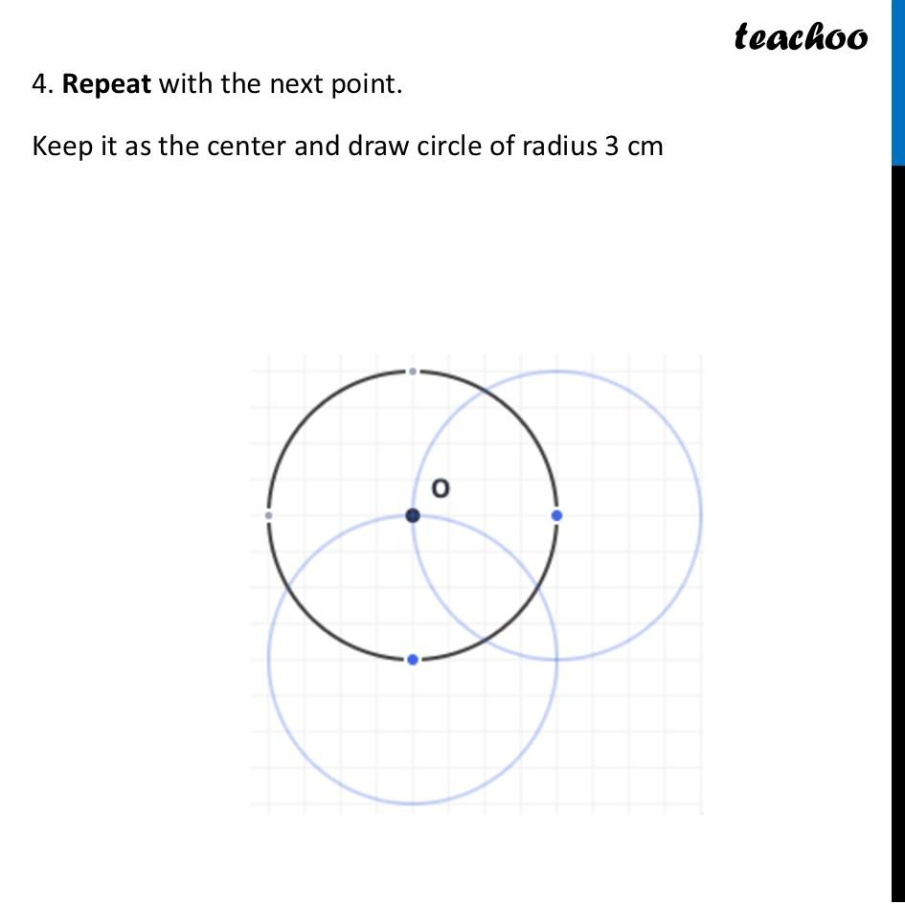


Radius Equality and Chords
# Source: AI Source: Provided by: [Data Path: Persons Table -> ID Column: 1, Name_En Column: Motasem Essam] -> From: [ChatGPT] on [7/25/2026]
The distance from the center to every point on the circle is the radius.
Therefore, if $A,B,C$lie on a circle centered at $O$:
$$\boxed{OA=OB=OC}.$$
This equality is independent of whether the points are connected by chords.
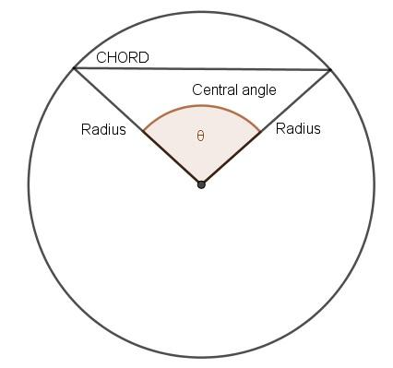
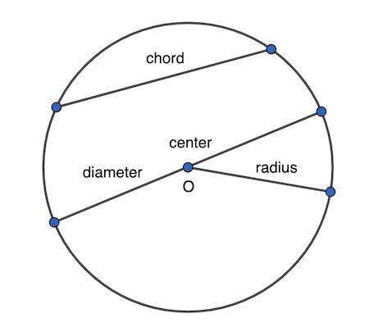
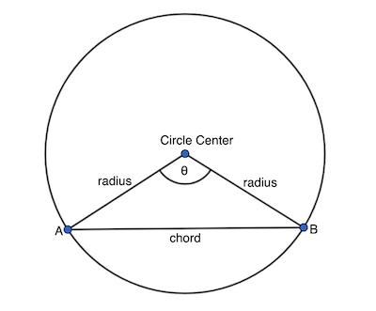
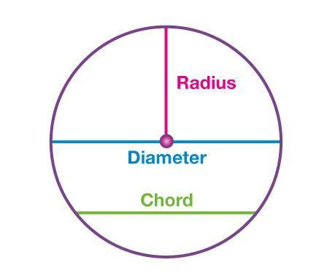
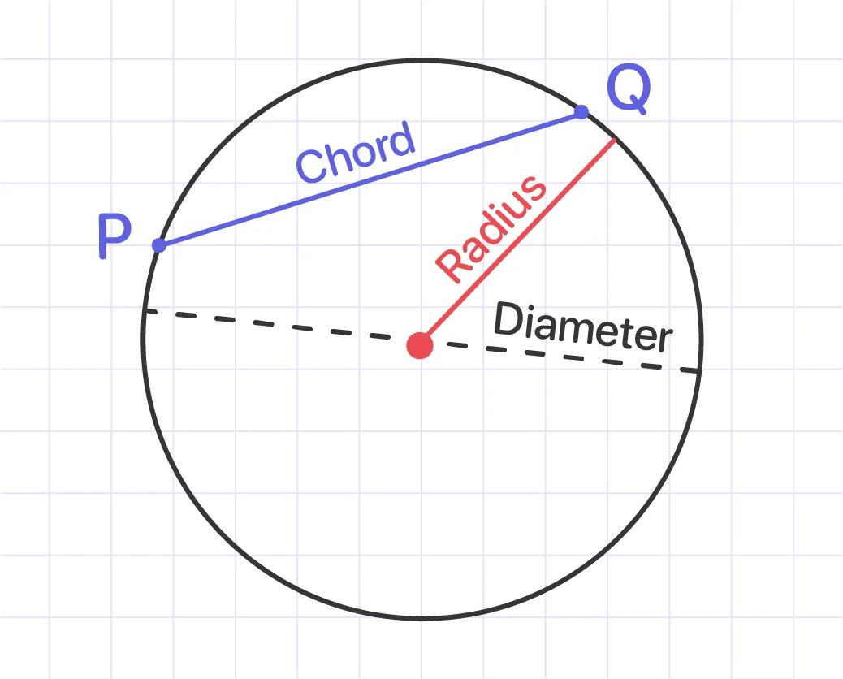
Important
Equal radii do not mean that all chords have equal lengths.
A chord closer to the center can be longer than another chord farther from the center.

Equality from Coordinate Geometry
# Source: AI Source: Provided by: [Data Path: Persons Table -> ID Column: 1, Name_En Column: Motasem Essam] -> From: [ChatGPT] on [7/25/2026]
For a circle centered at:
$$O=\left(h , k\right)$$
and a point:
$$A=\left(x , y\right)$$
on the circle, the radius is:
$$\boxed{r=\sqrt{{\left(x-h\right)}^{2}+{\left(y-k\right)}^{2}}}$$
Example
Let:
$$O=\left(0 , 0\right)$$
and:
$$A=\left(3 , 4\right).$$
Then:
$$r=\sqrt{3^{2}+4^{2}} \\ =\sqrt{25} \\ =5.$$
Therefore:
$$\boxed{r=5}.$$
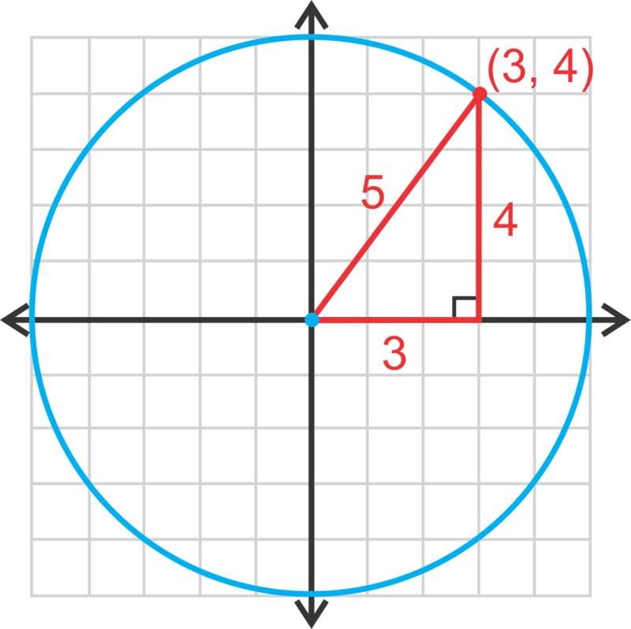
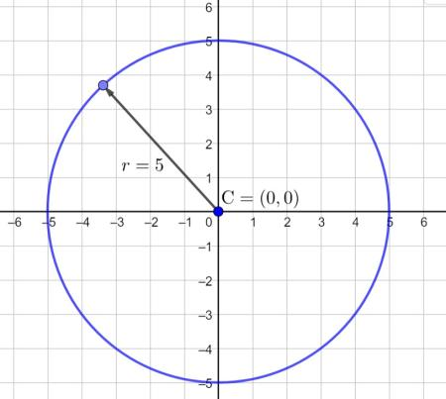
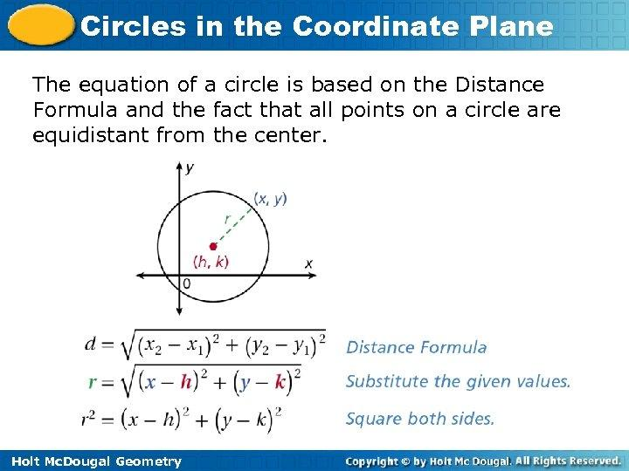

Equality from Coordinate Distances
# Source: AI Source: Provided by: [Data Path: Persons Table -> ID Column: 1, Name_En Column: Motasem Essam] -> From: [ChatGPT] on [7/25/2026]
Suppose two circles have centers and points such that:
$$r_{1}=\sqrt{{\left(x_{1}-h_{1}\right)}^{2}+{\left(y_{1}-k_{1}\right)}^{2}}$$
and:
$$r_{2}=\sqrt{{\left(x_{2}-h_{2}\right)}^{2}+{\left(y_{2}-k_{2}\right)}^{2}}.$$
If the calculated values are equal:
$$r_{1}=r_{2},$$
then the circles have equal radii.
Example
Circle A:
$$O_{1}=\left(0 , 0\right), A=\left(3 , 4\right)$$
gives:
$$r_{1}=5.$$
Circle B:
$$O_{2}=\left(10 , 10\right), B=\left(13 , 14\right)$$
gives:
$$r_{2}=5.$$
Therefore:
$$\boxed{r_{1}=r_{2}=5}.$$

Equality from Circle Equations
# Source: AI Source: Provided by: [Data Path: Persons Table -> ID Column: 1, Name_En Column: Motasem Essam] -> From: [ChatGPT] on [7/25/2026]
A circle has the standard equation:
$$\boxed{{\left(x-h\right)}^{2}+{\left(y-k\right)}^{2}=r^{2}}.$$
The value on the right determines the radius.
Example
Circle A:
$${\left(x-2\right)}^{2}+{\left(y-3\right)}^{2}=25.$$
Therefore:
$$r_{A}=\sqrt{25}=5.$$
Circle B:
$${\left(x+4\right)}^{2}+{\left(y-1\right)}^{2}=25.$$
Therefore:
$$r_{B}=\sqrt{25}=5.$$
Thus:
$$\boxed{r_{A}=r_{B}}.$$
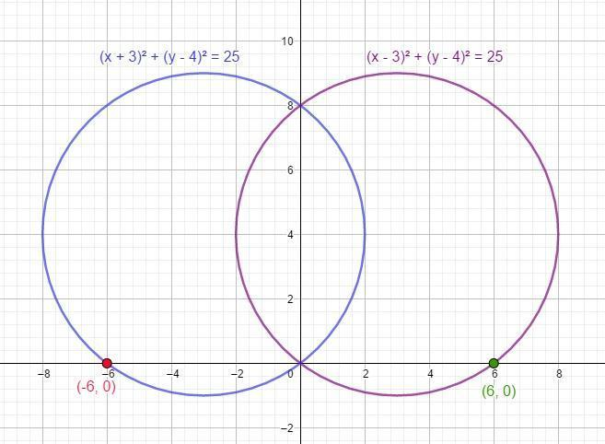
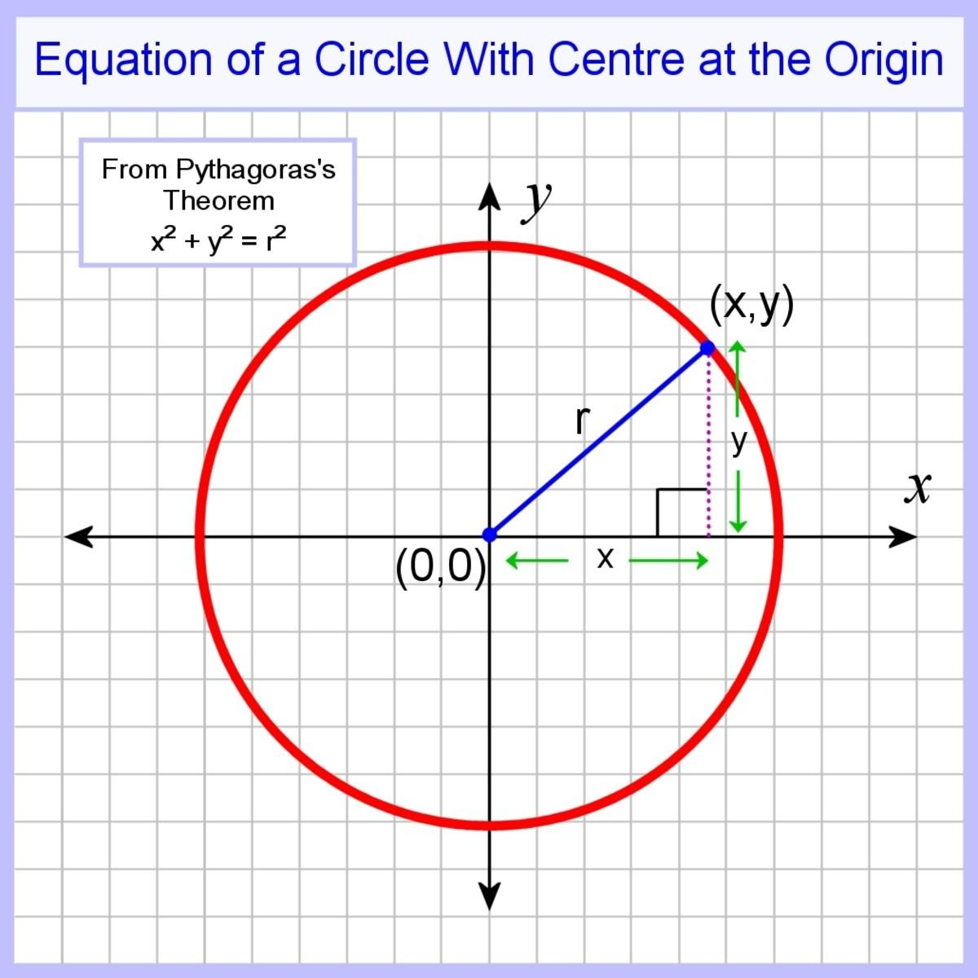
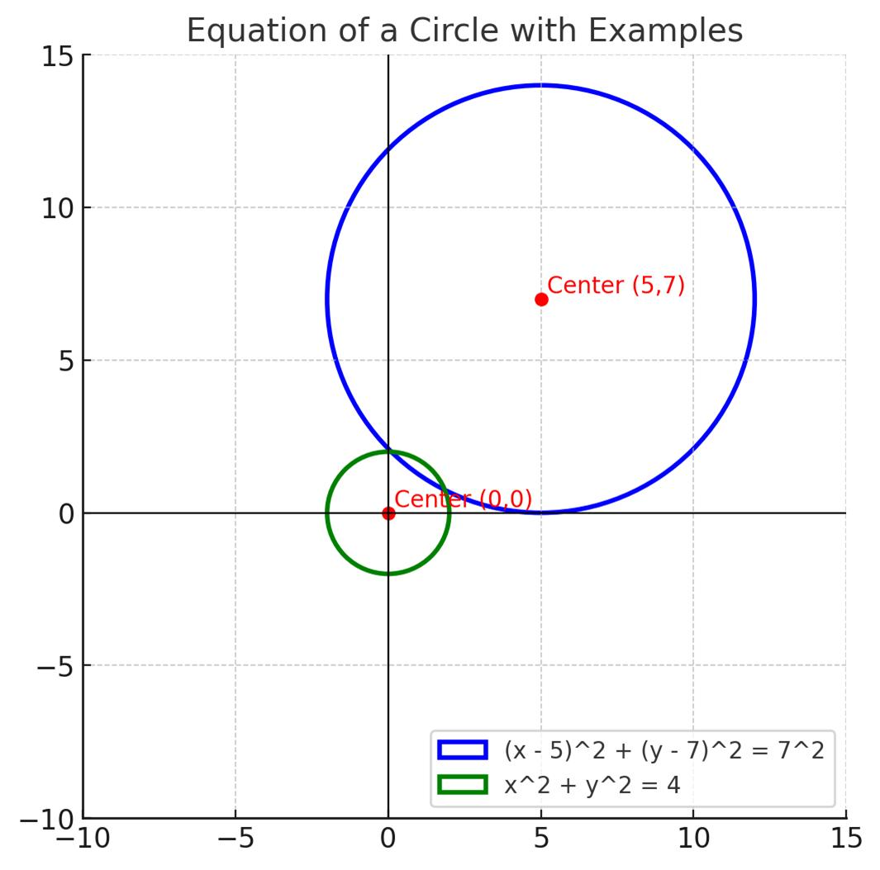

Algebraic Radius Equality
# Source: AI Source: Provided by: [Data Path: Persons Table -> ID Column: 1, Name_En Column: Motasem Essam] -> From: [ChatGPT] on [7/25/2026]
Suppose:
$$r_{1}=3x+2$$
and:
$$r_{2}=5x-10.$$
For radius equality:
$$3x+2=5x-10.$$
Therefore:
$$12=2x \\ x=6.$$
Then:
$$r_{1}=3\left(6\right)+2=20$$
and:
$$r_{2}=5\left(6\right)-10=20.$$
Therefore:
$$\boxed{r_{1}=r_{2}=20}.$$

Radius Equality and Circumference Equality
# Source: AI Source: Provided by: [Data Path: Persons Table -> ID Column: 1, Name_En Column: Motasem Essam] -> From: [ChatGPT] on [7/25/2026]
For a circle:
$$C=2πr.$$
Therefore:
$$r_{1}=r_{2}$$
implies:
$$2πr_{1}=2πr_{2}.$$
Hence:
$$\boxed{C_{1}=C_{2}}.$$
Conversely:
$$C_{1}=C_{2}$$
implies:
$$\boxed{r_{1}=r_{2}}.$$
Thus:
$$\boxed{\text{Radius Equality }⟺\text{ Circumference Equality}}$$
for circles.

Radius Equality and Diameter Equality
# Source: AI Source: Provided by: [Data Path: Persons Table -> ID Column: 1, Name_En Column: Motasem Essam] -> From: [ChatGPT] on [7/25/2026]
Because:
$$d=2r,$$
we have:
$$\boxed{r_{1}=r_{2} ⟺ d_{1}=d_{2}}$$
Example
If:
$$r_{1}=r_{2}=6,$$
then:
$$d_{1}=d_{2}=12.$$
Thus equal radii produce equal diameters.

Radius Equality and Area Equality
# Source: AI Source: Provided by: [Data Path: Persons Table -> ID Column: 1, Name_En Column: Motasem Essam] -> From: [ChatGPT] on [7/25/2026]
The area of a circle is:
$$A=πr^{2}.$$
Therefore:
$$r_{1}=r_{2}$$
implies:
$$πr_{1}^{2}=πr_{2}^{2}.$$
Hence:
$$\boxed{A_{1}=A_{2}}.$$
Example
Two circles have:
$$r_{1}=r_{2}=5.$$
Then:
$$A_{1}=A_{2}=25π.$$
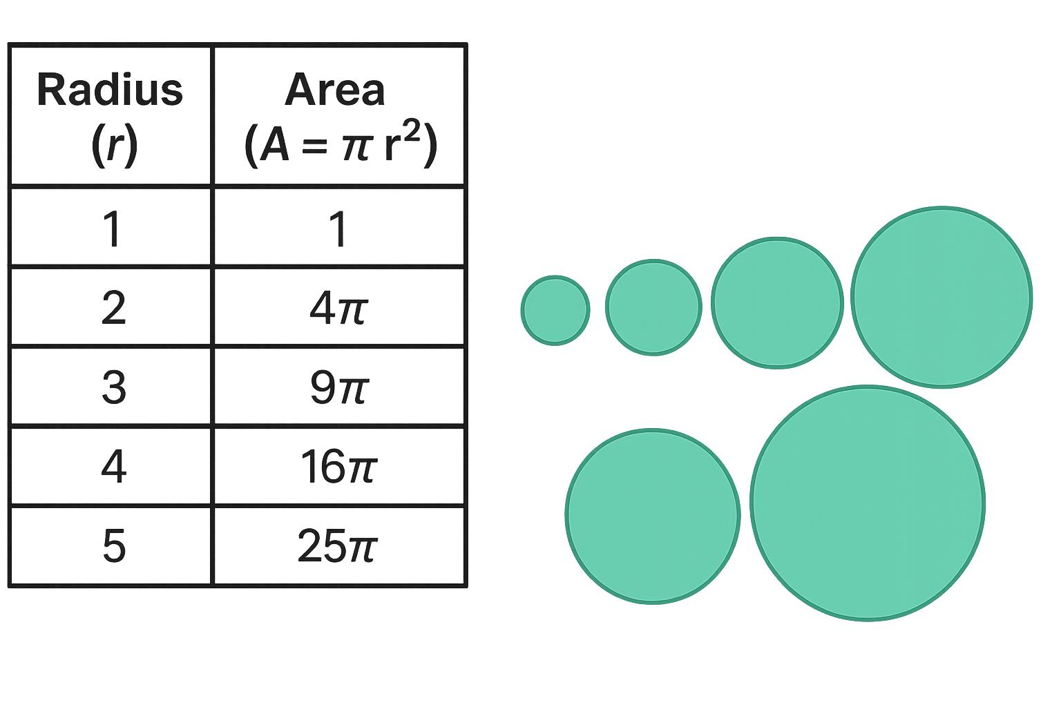
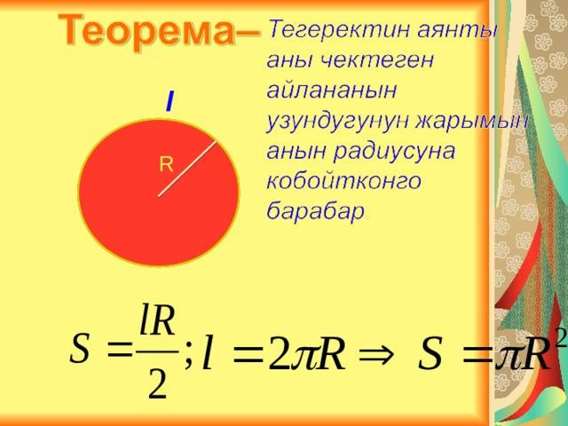
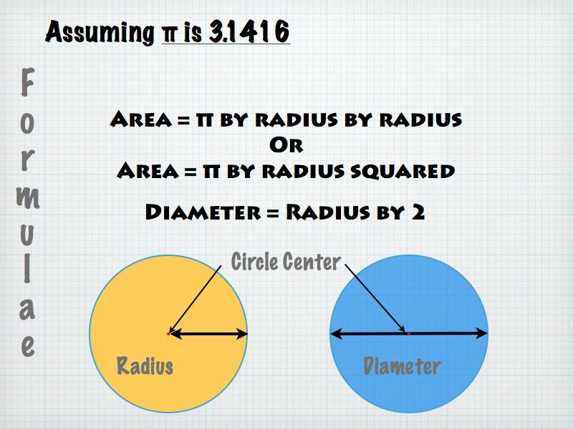

Radius Equality vs Diameter Equality
# Source: AI Source: Provided by: [Data Path: Persons Table -> ID Column: 1, Name_En Column: Motasem Essam] -> From: [ChatGPT] on [7/25/2026]
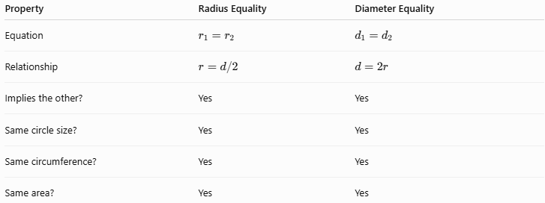
Property | Radius Equality | Diameter Equality
Equation | $$r_{1}=r_{2}$$ | $$d_{1}=d_{2}$$
Relationship | $$r=d/2$$ | $$d=2r$$
Implies the other? | Yes | Yes
Same circle size? | Yes | Yes
Same circumference? | Yes | Yes
Same area? | Yes | Yes
Therefore:
$$\boxed{\text{Radius Equality }⟺\text{ Diameter Equality}}$$
for circles.

Radius Equality vs Segment-Length Equality
# Source: AI Source: Provided by: [Data Path: Persons Table -> ID Column: 1, Name_En Column: Motasem Essam] -> From: [ChatGPT] on [7/25/2026]
A radius is a special line segment.
Therefore, Radius Equality is a specialized form of segment-length equality:
$$\boxed{\text{Radius Equality}⊂\text{Segment-Length Equality}}$$
For example:
$$AB=CD$$
could refer to any two equal segments.
But if $OA$and $OB$are radii of the same circle:
$$\boxed{OA=OB}$$
is specifically Radius Equality.

Radius Equality vs Distance Equality
# Source: AI Source: Provided by: [Data Path: Persons Table -> ID Column: 1, Name_En Column: Motasem Essam] -> From: [ChatGPT] on [7/25/2026]
Radius is also a distance:
$$\boxed{r=d\left(O , A\right)}$$
where $O$is the center and $A$is a point on the circle.
Therefore:
$$\boxed{OA=OB}$$
can be described both as:
- Radius Equality, because $OA$and $OB$are radii;
- Distance Equality, because the distances from $O$to $A$and $B$are equal.
This shows that categories of Geometric Equality can overlap.

Radius Equality in Geometric Proofs
# Source: AI Source: Provided by: [Data Path: Persons Table -> ID Column: 1, Name_En Column: Motasem Essam] -> From: [ChatGPT] on [7/25/2026]
Suppose $A,B,C$lie on a circle centered at $O$.
By the definition of a circle:
$$OA=r, \\ OB=r,$$
and:
$$OC=r.$$
Therefore:
$$\boxed{OA=OB=OC}.$$
This radius equality is frequently used to prove that triangles involving the center are isosceles.
For example:
$$OA=OB$$
implies:
$$△OAB$$
is isosceles.
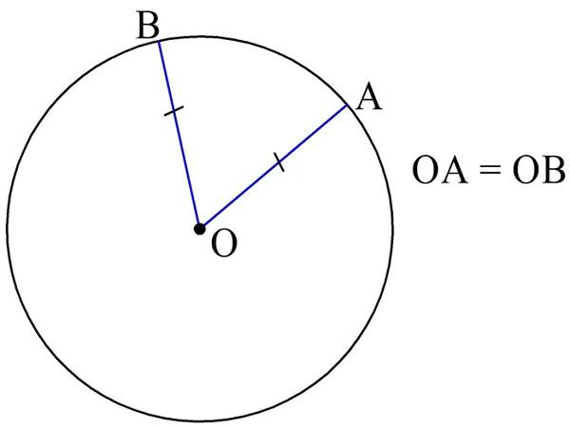
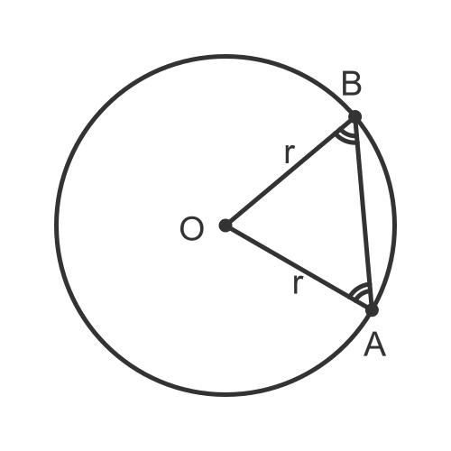
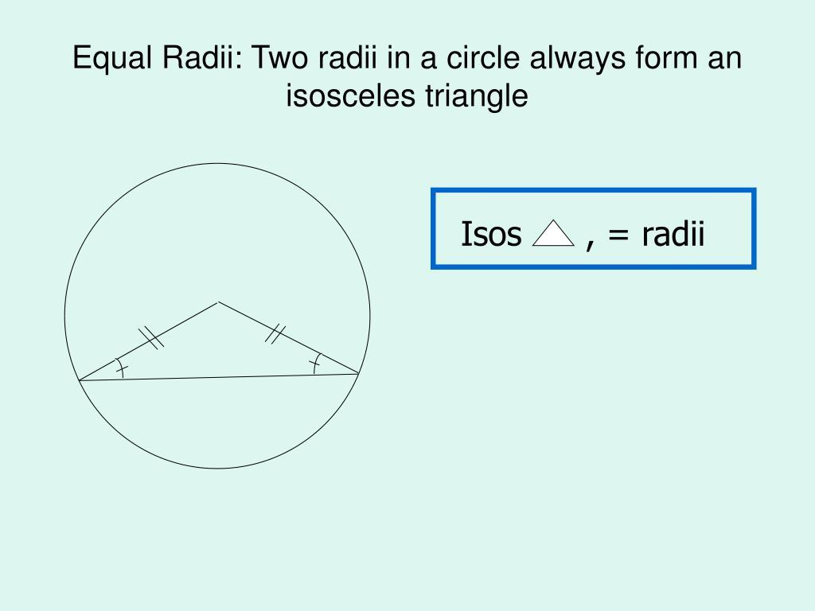
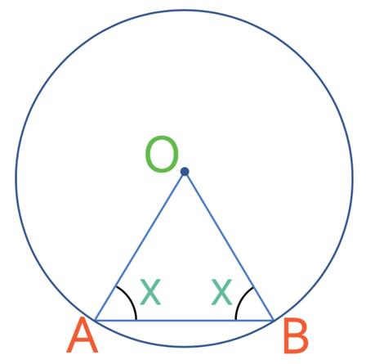

Important Radius Formulas
# Source: AI Source: Provided by: [Data Path: Persons Table -> ID Column: 1, Name_En Column: Motasem Essam] -> From: [ChatGPT] on [7/25/2026]
Radius from diameter
$$\boxed{r=\frac{d}{2}}$$
Diameter from radius
$$\boxed{d=2r}$$
Circumference
$$\boxed{C=2πr}$$
Area
$$\boxed{A=πr^{2}}$$
Radius from circumference
$$\boxed{r=\frac{C}{2π}}$$
Radius from area
$$\boxed{r=\sqrt{\frac{A}{π}}}$$
Coordinate distance
$$\boxed{r=\sqrt{{\left(x-h\right)}^{2}+{\left(y-k\right)}^{2}}}$$

Classification Summary
# Source: AI Source: Provided by: [Data Path: Persons Table -> ID Column: 1, Name_En Column: Motasem Essam] -> From: [ChatGPT] on [7/25/2026]
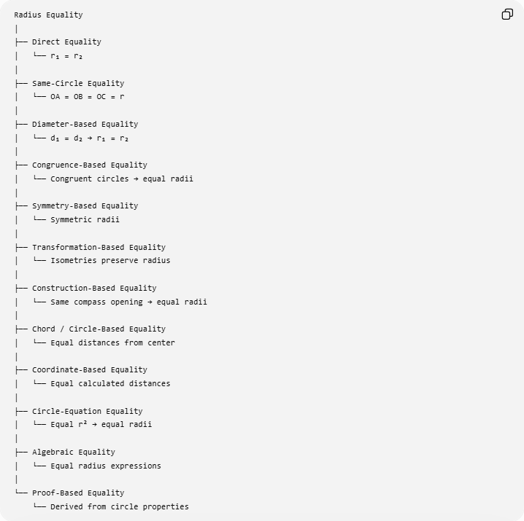
Radius Equality
│
├── Direct Equality
│ └── r₁ = r₂
│
├── Same-Circle Equality
│ └── OA = OB = OC = r
│
├── Diameter-Based Equality
│ └── d₁ = d₂ → r₁ = r₂
│
├── Congruence-Based Equality
│ └── Congruent circles → equal radii
│
├── Symmetry-Based Equality
│ └── Symmetric radii
│
├── Transformation-Based Equality
│ └── Isometries preserve radius
│
├── Construction-Based Equality
│ └── Same compass opening → equal radii
│
├── Chord / Circle-Based Equality
│ └── Equal distances from center
│
├── Coordinate-Based Equality
│ └── Equal calculated distances
│
├── Circle-Equation Equality
│ └── Equal r² → equal radii
│
├── Algebraic Equality
│ └── Equal radius expressions
│
└── Proof-Based Equality
└── Derived from circle properties

Relationship to Geometric Equality
# Source: AI Source: Provided by: [Data Path: Persons Table -> ID Column: 1, Name_En Column: Motasem Essam] -> From: [ChatGPT] on [7/25/2026]
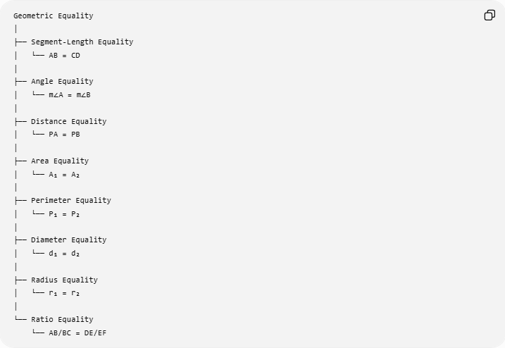
Geometric Equality
│
├── Segment-Length Equality
│ └── AB = CD
│
├── Angle Equality
│ └── m∠A = m∠B
│
├── Distance Equality
│ └── PA = PB
│
├── Area Equality
│ └── A₁ = A₂
│
├── Perimeter Equality
│ └── P₁ = P₂
│
├── Diameter Equality
│ └── d₁ = d₂
│
├── Radius Equality
│ └── r₁ = r₂
│
└── Ratio Equality
└── AB/BC = DE/EF
Radius Equality is therefore a specialized type of geometric length/distance equality associated with circles.

Key Points
# Source: AI Source: Provided by: [Data Path: Persons Table -> ID Column: 1, Name_En Column: Motasem Essam] -> From: [ChatGPT] on [7/25/2026]
- Radius Equality means:
$$\boxed{r_{1}=r_{2}}$$
- All radii of the same circle have equal lengths:
$$\boxed{OA=OB=OC=r}.$$
- Radius and diameter are related by:
$$\boxed{d=2r}.$$
- Therefore:
$$\boxed{r_{1}=r_{2} ⟺ d_{1}=d_{2}}.$$
- Equal radii of circles imply equal circumferences:
$$\boxed{C_{1}=C_{2}}.$$
- Equal radii of circles imply equal areas:
$$\boxed{A_{1}=A_{2}}.$$
- Equal radii of circles imply congruent circles.
- Concentric circles do not necessarily have equal radii.
- Isometries preserve radius.
- Scaling changes radius according to:
$$\boxed{r^{'}=kr}.$$
- A radius is both a special segment and a distance from the center to the circle.

Conclusion
# Source: AI Source: Provided by: [Data Path: Persons Table -> ID Column: 1, Name_En Column: Motasem Essam] -> From: [ChatGPT] on [7/25/2026]
Radius Equality is the exact equality between the lengths of two or more radii:
$$\boxed{r_{1}=r_{2}}.$$
For a single circle, every radius has the same length. For two circles, equal radii mean that the circles have the same size and therefore the same diameter, circumference, and area.
$$\boxed{r_{1}=r_{2} ⟺ d_{1}=d_{2}}$$
and for circles:
$$\boxed{r_{1}=r_{2}⇒C_{1}=C_{2}⇒A_{1}=A_{2}}$$
Thus, Radius Equality is one of the fundamental circle-based forms of Geometric Equality.

